- Universal containers uses a custom object called candidates to track information about people who are being recruited for jobs within the company. Employees should be able to create a candidate record; however, only hr users should be able to view, edit, and report on the salary field. Which action should be recommended for controlling who can view the salary field?
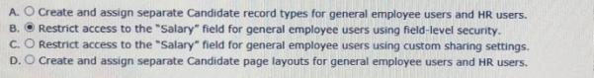
Ans: B
- What are two capabilities of record types?
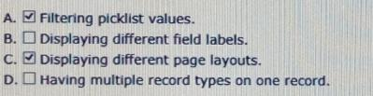
Ans: A C
- What are two capabilities of schema builder?
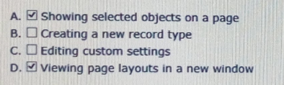
Ans: A D
- An app builder at universal containers wants to prevent users from creating new records on an account related list by overriding standard buttons. Which two aspects should the app builder consider before overriding standard buttons?
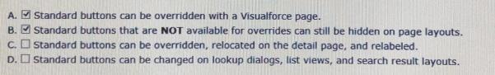
Ans: A B
- Which two objects can be members of a campaign?
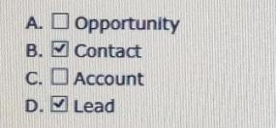
Ans: B D
- Universal containers manages internal projects by department using a custom object called projects. Only employees in the project’s respective department should have view access to all of the department’s project records. If an employee changes job roles and moves to another department, the employee should no longer have access to the projects within their former department. Which two options will meet these requirements assuming the organization-wide default for projects is set to private?
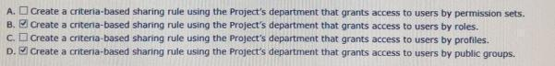
Ans: B D
- At universal containers, the vp of service has requested a visual indicator flag on each case, based on the case priority. High-priority cases should be flagged red, medium-priority should be flagged yellow, and low-priority cases should be flagged green. Which two formulas will accomplish this requirement?
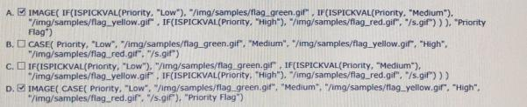
Ans: A D
- Universal containers sells to three different types of organizations: Partner, enterprise, and small business. Some of the information collected about each organization overlaps; however, there are also unique attributes to each type of organization that need to be tracked, some of which are required. Which solutions meet these requirements?
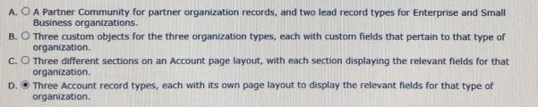
Ans: D
- What is true when creating custom report types?
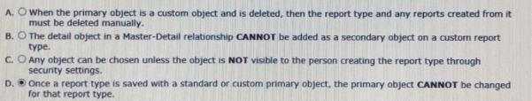
Ans: D
- The vp of marketing wants to broadcast an email to 10,000 contacts in salesforce on a regular basis, but realizes salesforce’s mass email functionality has a limitation on the number of emails that can be sent each day. What action should the app builder take?
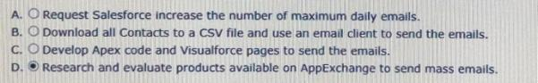
Ans: D
- Which two report formats can be used as a source report to configure a reporting snapshot?
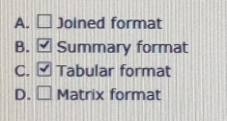
Ans: B C
- Which two statements are true about field update actions from workflow rules and approval processes?
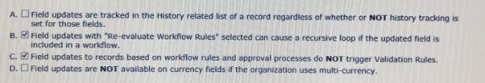
Ans: B C
- Which three statements are true about master-detail relationships?
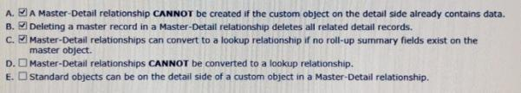
Ans: A B C
- An app builder needs to change the data types of a custom field. The app builder is not allowed to delete and recreate any of the fields or modify any apex code. Which data type change will require the app builder to perform additional steps in order to retain existing functionality?
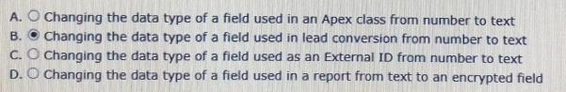
Ans: B
- Universal containers uses a private sharing model for opportunities. This model cannot be changed due to a regional structure. A new sales operations team has been created. This team needs to perform analysis on opportunity data, and should have read and write access to all opportunities. What are two recommended solutions for the app builder to give the users appropriate access?
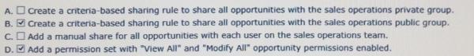
Ans: B D
- Universal containers is setting up salesforce for the first time. Management wants the sales and marketing teams to have different navigation menus in the salesforce mobile app. Which option is available to an app builder to satisfy this requirement?
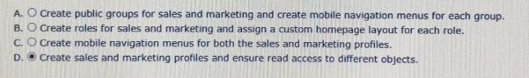
Ans: D
- Universal containers wants to test code against a subset of production data that is under 5 GB. Additionally, universal containers wants to refresh this sandbox every weekend. Which type of sandbox should be used to accomplish this?
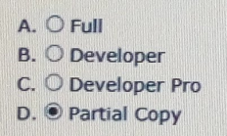
Ans: D
- Universal containers needs to send an outbound message to an external system when a record has been updated. What is the recommended feature to meet this requirement?
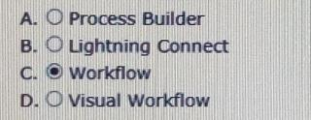
Ans: C
- Universal containers wants to automatically assign a specific permission set to new users. Which two actions should be completed to meet this requirement?
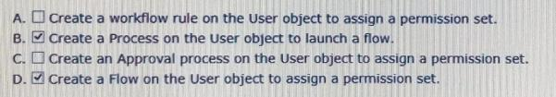
Ans: B D
- Universal containers (UC) uses a custom object to track expense reports. UC wants to automatically post updates on a record’s feed whenever an expense report has been approved. Which social feature can be used to accomplish this?
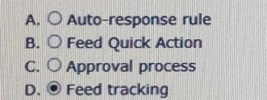
Ans: D
- Representatives at universal containers use salesforce to record information for new leads. When new prospects are added. An outbound message is sent to sap with the lead’s information. Which automation process will accomplish this without writing any code?
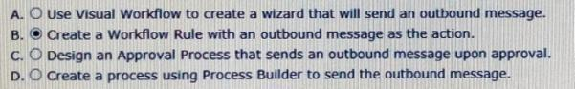
Ans: B
- At universal containers, multiple departments utilize the case object for different purposes. Some users submit cases while other users provide customer support with case records. What is the minimum required configuration for an app builder to enable different users to see different fields, based on the case type?
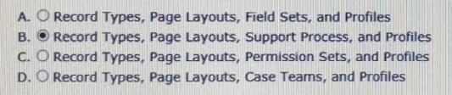
Ans: B
- Universal containers wants to embed a chart of all related opportunities, by stage, on the account detail page. Which type of report should an app builder create to add to the account page layout?
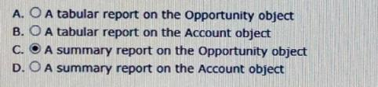
Ans: C
- Which three statements are true about converting a lead?
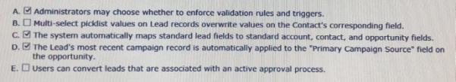
Ans: A C D
- Universal containers (UC) wants to streamline its data capture process by linking fields together. UC wants to do this so that the available values on dependent fields are driven by values selected on controlling fields. Which three considerations support the stated requirements?
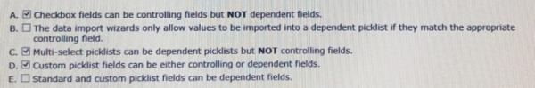
Ans: A C D
- The training team at universal containers uses a custom training object to track customer training sessions. An app builder needs to create a relationship between the training object and the related students’ record. Which two statements are true when creating a student lookup field on the training object?
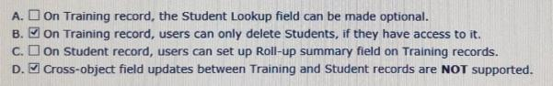
Ans: B D
- Which two statements are true about an external id field?
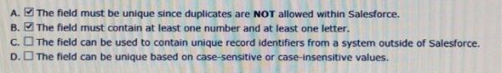
Ans: A B
- Universal containers want to collaborate with its customers within salesforce, and has decided to enable the allow customer invitations chatter setting. Which permission is granted to customers when invited to a chatter group?
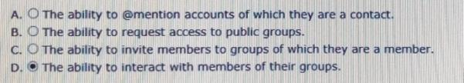
Ans: D
- Universal containers needs to update a field on an account when a opportunity stage is changed to closed lost. Which two tools should be used to accomplish this requirement?
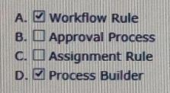
Ans: A D
- Universal containers has a requirement that an opportunity should have a field showing the value of its associated account’s billing state. This value should not change after the opportunity has been created. What is the recommended solution to configure this automation behavior?
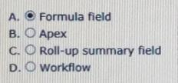
Ans: A
- Sales representatives want to capture custom feedback record details related to each account. The sales reps want to accomplish this with minimal clicks on the salesforce mobile application. Which two solutions should be recommended in order to meet this requirement?
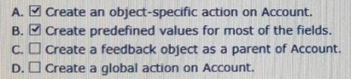
Ans: A B
- Universal containers has a customer base where many customers have the same or similar company names. Which functionality should be configured to improve an end user’s search experience?
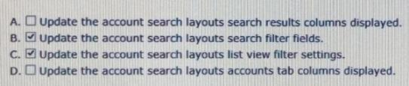
Ans: B C
- Universal containers wants sales reps to get permission from their managers before deleting opportunities. What can be used to meet these requirements?
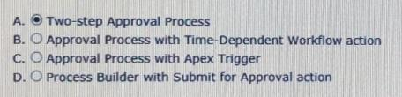
Ans: A
- Universal containers has created the custom objects candidate and interview in salesforce to track candidates and interviews respectively. The company wants to track the total number of interviews a candidate has gone through on the candidate record without writing any code. Which two actions should an app builder take to accomplish this requirement?
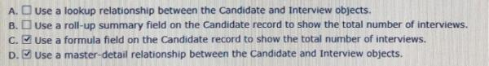
Ans: C D
- Which three field types can be referenced by a roll-up summary field using sum?
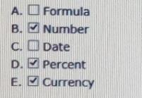
Ans: B D E
- The director of customer service wants to receive a notification when a case stays in the new status for more than four business hours. Which two automation processes should be used to accomplish this?
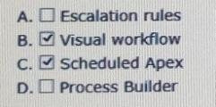
Ans: B C
- An app builder has been asked to provide users a way to identify a contact’s preferred contact method directly on the contact record. Users need to be able to identify whether a phone number or an email is the contact’s preferred communication method. Which field type will allow the app builder to accomplish this with the fewest fields possible?
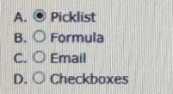
Ans: A
- An app builder wants to show groups as the last navigation menu item in the salesforce mobile app. However, the app builder is not able to select groups as one if the items on the drop-down menu. What could cause this?
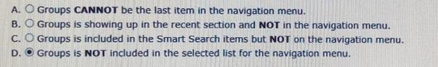
Ans: D
- Which two relationship types can be defined with external objects?
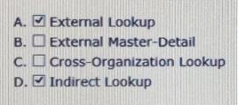
Ans: A D
- Which two are key considerations when using unmanaged packages?
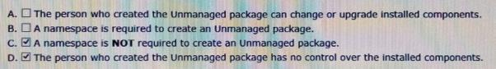
Ans: C D
- When an opportunity close date is delayed by more than 60 days, the manager and the vp of sales must approve the change. Which two solutions will meet the requirement?
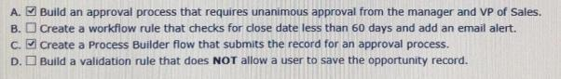
Ans: A C
- Which two behaviors may occur if workflow rules are reevaluated after a field change by a field update?
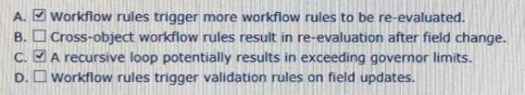
Ans: A C
- At universal containers, the account object has a master-detail relationship with an invoice custom object. The app builder wants to change this to a lookup field, but is not able to do so. What could be causing this?
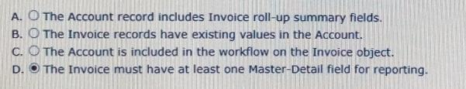
Ans: D
- Universal containers has purchased a lightning component on the appexchange. In which two areas can these components be utilized?
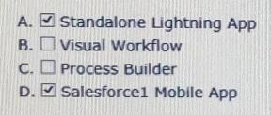
Ans: A D
- When is it recommended to refresh a full sandbox?
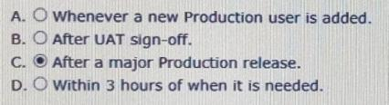
Ans: C
- Which two statements are true when a new full sandbox is created?
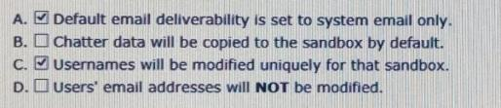
Ans: A C
- Universal containers has deployed custom tabs to production via change sets, without including the profile settings. What is true about the visibility of custom tabs in enterprise edition?
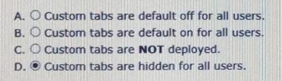
Ans: D
- The vp of account management at universal containers has requested that all contacts’ mailing postal codes match the associated account’s shipping postal code. How can this be enforced using validation rules?
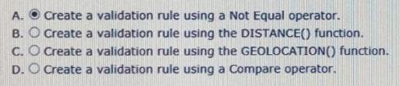
Ans: A
- An app builder is loading data into salesforce. To link the new records back to the legacy system, a field will be used to track the legacy id on the account object. For future data loads this id will be used when upserting records. Which two field attributes should be selected?
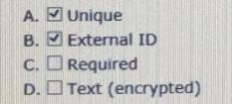
Ans: A B
- The app builder at universal containers has been asked to ensure that the country field on the account object is captured as the two-letter abbreviation. How can the app builder satisfy this requirement?
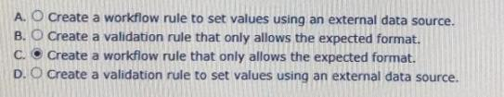
Ans: C
- A new custom object is being created with a private sharing setting. The business wants to share individual records with specific people or groups of people on a case-by-case basis. Which three options does the business user have to manually share individual records?
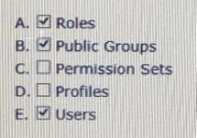
Ans: A B E
- Which two statements are true about record types?
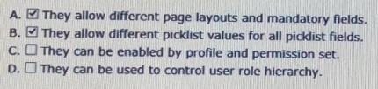
Ans: A B
- A business user wants a quick way to edit a record’s status and enter a custom due date field from the record’s feed in salesforce mobile app. What could be used to accomplish this?
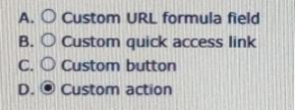
Ans: D
- Universal containers sales reps can modify fields on an opportunity until it is closed. Only the sales operations team can modify the post-close follow-up date and post-close follow-up comments fields. How can these requirements be met?
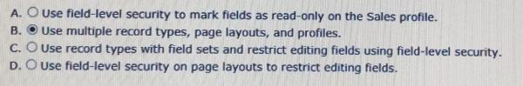
Ans: B
- Universal containers conducts evaluations of their sales reps using a custom object consisting of numerical scores and executive comments. The company wants to ensure that only the sales reps, their managers, and their manager’s executives can view the rep’s evaluation record, but the reps should not be able to view the executive comment fields on their review. How can these requirements be met?
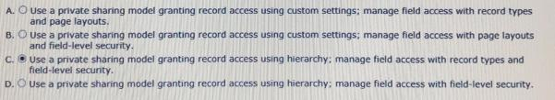
Ans: C
- The organization-wide default for a custom object is set to private. The supervisor profile grants view access to the same object. A user with the supervisor profile is also listed as the manager on the user detail records for a subordinate. However, the supervisor still cannot view records owned by the subordinate. Which two issues are preventing the supervisor from viewing records owned by the subordinate?
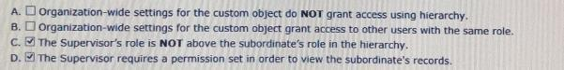
Ans: C D
- A custom field contains a feedback score which is on a scale of one to five. End users would like a visual indicator of one to five stars based on the number found in the feedback score custom field. How can this visual indicator be displayed?
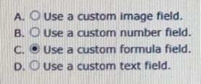
Ans: C
- A customer service representative at a call center wants to be able to collect information from customers using a series of question prompts. What could be used to accomplish this?
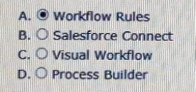
Ans: A
- When configuring a record type, an app builder can configure the available value of a picklist field for the page layout. Which two opportunity standard fields are available to be configured directly in the opportunity record type?
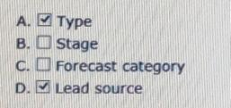
Ans: A D
- The marketing team at universal containers has a list of 400 leads it wants to upload to salesforce. The team needs to avoid creating duplicate records. Which two actions should be taken to meet this requirement?
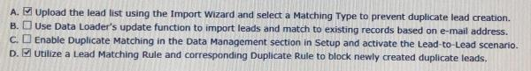
Ans: A D
- Universal containers wants to show different picklist values to different groups of users in a custom picklist field. What should be configured?
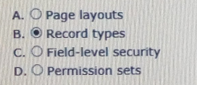
Ans: B
- Which two features can extend record access beyond the organization-wide defaults?
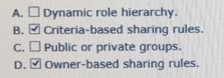
Ans: B D
- Which two features can be used to allow users to access flows?
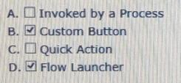
Ans: B D
- A manger at universal containers has requested that a custom text field be converted to a picklist in order to promote better data hygiene. Which two actions should be considered before changing the field type?
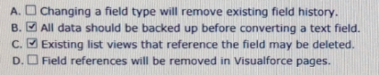
Ans: B C
- What is a use case for validation rules?
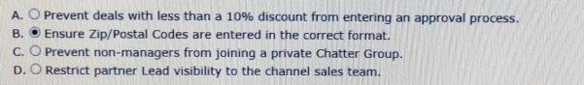
Ans: B
- A custom object has a public read only sharing setting that does not grant access using hierarchies. A dynamic sharing rule provides write access to the object to the global marketing public group if the record is marked as global. A user creates a new record and marks it as global. Who will have write access to the record?
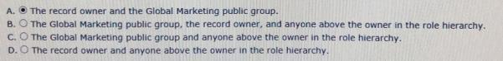
Ans: A
- Universal containers wants to collaborate with its customers within salesforce, and has decided to enable the “ allow customer invitations “ chatter setting. Which permission is granted to customers when invited to a chatter group?
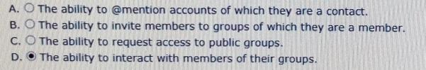
Ans: D
- Which sandbox type allows for the use of a sandbox template?
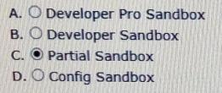
Ans: C
- Universal containers uses a private account sharing model. They have a process improvement team with representatives from multiple departments that needs to view all accounts that have been flagged as problem accounts. How should this team be granted access to the records?
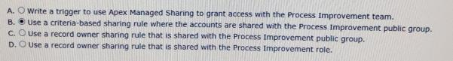
Ans: B
- A manger wants to calculate the number of days since an account was last contacted through email. Which field type should be used to accomplish this?
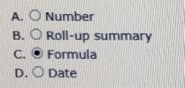
Ans: C
- The vp of sales at universal containers wants to have a set of screens to guide the inside sales team through collecting and updating data for leads. How can the app builder accomplish this?
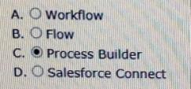
Ans: C
- A custom field on an account is used to track finance information about a customer. Only members of the finance team have access to this field. However, the business wants to allow one customer service agent, who is assigned the customer service profile, read-only access to this field for special circumstances. What is the recommended solution to grant the customer service agent access to the field?
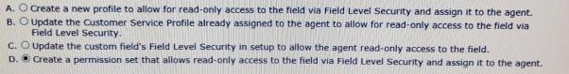
Ans: D
- Universal containers has two types of customer support processes: platinum and diamond. The app builder created separate record types for each process on the case object. The customer support team should not be able to create new cases with the diamond record typ. How can this requirement be met?
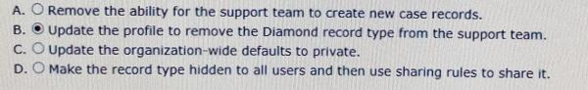
Ans: B
- Which feature can an app builder use to automatically assign cases that have been open longer than three days to the next support tier?
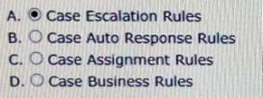
Ans: A
- Which two solutions prevent a formula field from being referenced by a roll-up summary field?
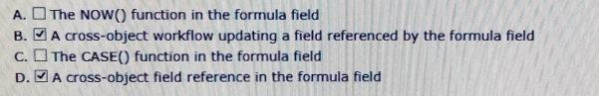
Ans: B D
- Universal containers needs to flag leads with one or more business areas. They need to add a field to capture these to the lead record. There is no need to report on this field. What is the appropriate field type?
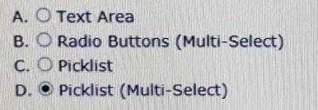
Ans: D
- A new custom object called invoices needs to have an invoice date for the date and time it was invoiced. Which field type should be selected for this?
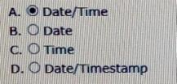
Ans: A
- Which three salesforce functionalities are ignored when processing field updates in workflow rules and approval processes?
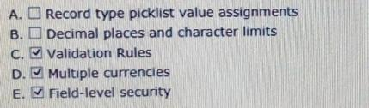
Ans: C D E
- An app builder has been asked to integrate salesforce with an external web service. The web service must be notified every time an opportunity is won. What are two ways to satisfy this requirement?
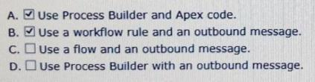
Ans: A B
- Universal containers wants to automate a business process using workflow. They are aware that workflow rules may cause recursive behavior, and as a result certain actions will only cause workflow rules that didn’t fire previously to be retriggered. Which workflow action might cause this behavior?
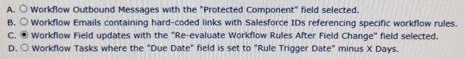
Ans: C
- An app builder wants to streamline the user experience by reflecting summarized calculations of specific fields on various objects. Which three field types could be used in roll-up summary fields to accomplish this?
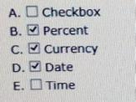
Ans: B C D
- Universal containers wants its field sales team to only see the accounts that they own. Separate north American and European marketing teams should only see accounts in their respective regions. The inside sales team needs to see all accounts in salesforce. How can this be accomplished?
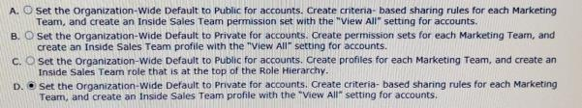
Ans: D
- Which two metadata changes can be made directly in a production environment without deploying from a sandbox?
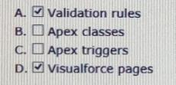
Ans: A D
- What is true when deleting a dashboard?
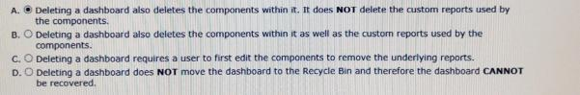
Ans: A
- The cfo wants to make sure that a deal with more than a 40% discount gets approved by the vp of finance before a quote is sent to the customer. In which two ways can this be accomplished?
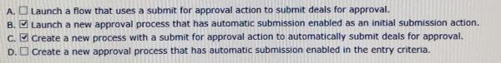
Ans: B C
- Which three standard component types are available in the lightning app builder?
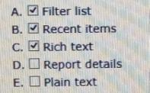
Ans: A B C
- Universal containers wants to optimize routes for its travelling service personnel. What is the recommended solution to meet this requirement?
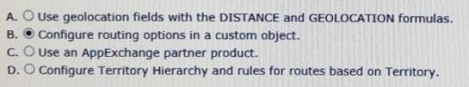
Ans: B
- An app builder creates an account validation rule on the industry field that will throw an error if the length of the field is longer than 6 characters. Another app builder creates a workflow rule with a field update that sets the industry field to technology whenever the billing city field is set to san Francisco. What will happen the next time a salesperson saves an account with a billing city of san Francisco?
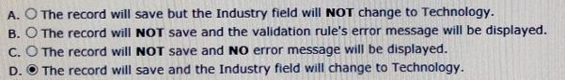
Ans: D
- Which two rules can be configured for the opportunity object?
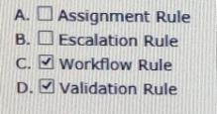
Ans: C D
- The vp of sales has requested that account site information should be visible on all opportunity records. What is the recommended solution to meet this requirement?
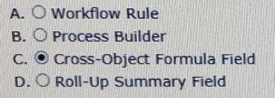
Ans: C
- Which two options are available to an app builder when defining an object-specific create record custom action?
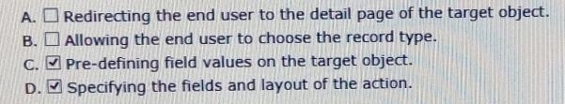
Ans: C D
- The director of marketing has asked the app builder to create a formula field that tracks how many days have elapsed since a contact was sent a marketing communication. The director is only interested in whole units. Which function should be used to return today’s date for calculating the difference?
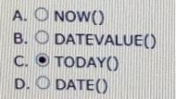
Ans: C
- What are two reasons to create an unmanaged package?
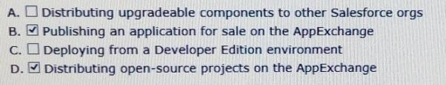
Ans: B D
- Universal containers require different fields to be filled out at each stage of the opportunity sales process. What configuration steps can an app builder use to meet this requirement?
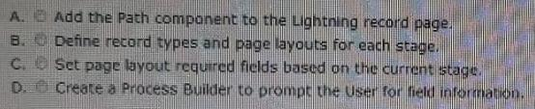
Ans: A
- Universal containers wants to track installation information once a container has been purchased on a custom object. Sales reps should have visibility of all the installations associated with their opportunities. What kind of relationship should this new object have to the opportunity?
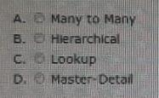
Ans: A
- Universal containers (UC) requires that all users specify a contract is sent on each opportunity prior to making it as “closed won”. Uc wants to be able to report on how many opportunities have sent contracts compared to how many have a missing contract when the opportunities closed. What type of field should an app builder configure to fulfill this requirement?
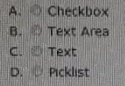
Ans: A
- Managers at universal containers want a quick way to create additional accounts to form a hierarchy from a parent account record. They want to auto-populate five fields based on the parent to make it easier for users to create the child accounts quickly. What should the app builder recommend?
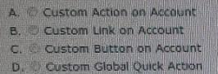
Ans: C
- The service manager would like to highlight case age. When a case is new, they would like to see a green flag on the case record. The flag should be yellow if the case is still open after one day. The flag should be red when cases are open after three days. Which two options should an app builder use to implement this requirement?
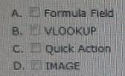
Ans: A D
- Universal containers has created two custom objects called seminars and attendees. Organization-wide defaults for these objects have been set to private. Universal containers wants to set up a new junction object between these custom objects. A select group of users should be able to edit records in the junction object. Which two steps should an app builder take to configure the proper security?
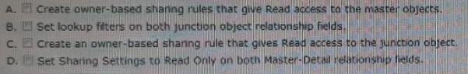
Ans: B C
- The convert button on leads should not appear until the lead status picklist is set to qualified. What should an app builder suggest to meet these requirements?
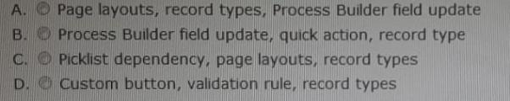
Ans: A
- Sales managers at universal containers would like to standardize what information sales reps are gathering. Sales reps want recommendations, sales strategies and to know what key fields need to be completed at each step of the sales processes on the opportunity record. What feature should an app builder use to provide this functionality?
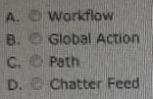
Ans: D
- Universal containers has several new fields they’ve requested for the opportunity product object. What should an app builder be able to configure using a formula field?
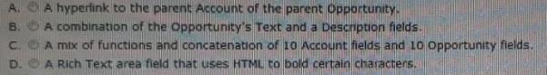
Ans: B
- A production org includes custom objects containing confidential information. A sandbox is needed that includes data records, excludes all of the confidential objects, and can be refreshed weekly. What steps should an app builder take to meet these requirements?
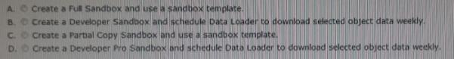
Ans: C
- Sales managers want to be automatically notified any time there is a change to an opportunity close date and want these changes to be tracked on the opportunity. Which two configurations should an app builder recommend?
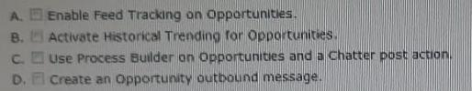
Ans: A B
- Universal containers (UC) wants to delete data in several fields for 5000 lead records. Uc exported the selected record ids and fields that need to have data deleted in a csv file. Which two steps should an app builder suggest to meet these requirements?
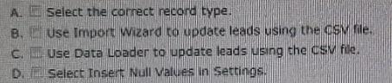
Ans: B C
- Service agents are required to confirm a user’s identity before providing support information over the phone. What feature can an app builder use to help agents meet this requirement?
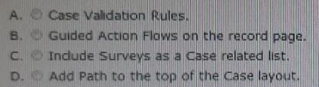
Ans: B
- Universal containers (UC) has several large customers that sell their products through dealers. Each customer and dealer has an individual rep who works directly with uc and each is billed separately. How can an app builder implement these requirements?
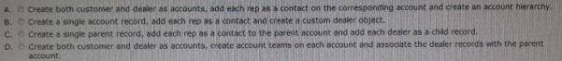
Ans: A
- Universal containers is migrating its sales operations from a legacy system that was used in Europe. Opportunities need to be imported with the proper country currency. Which two steps should an app builder configure to meet these requirements?
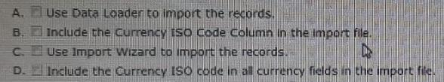
Ans: A D
- After universal containers converts qualified leads, sales reps need to be able to report on converted leads. How should an app builder support for this requirement?
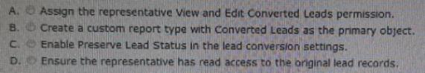
Ans: B
- Universal containers (UC) wants to build a recruiting app that allows for multiple positions to appear on custom objects websites and postings. Uc requires a report that shows the related custom objects of postings. Which two items should an app builder configure to implement this?
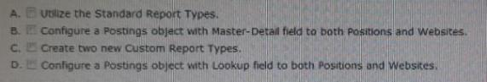
Ans: B D
- Universal containers has implemented multi-currency. There are several products that universal containers sells exclusively in Europe and the uk. Opportunities for these products need to be written in euros (EUR) or british pounds (GBP). Which solution should an app builder recommend?
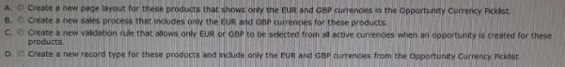
Ans: D
- Universal containers has a new custom object for invoices that includes an invoicenumber field. Before the invoice object can be used, invoices will be migrated from an external system maintaining their current invoicenumber. After the migration, salesforce will be the system of record and each new invoice created in salesforce must have a unique invoicenumber. How should the app builder configure the invoicenumber field?
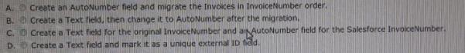
Ans: D
- Duplicate management for leads has been implemented at universal containers but it seems duplicate leads are still being created. The org wide default (OWD) is set to “private” for leads. Which two actions help prevent duplicate leads from being created?
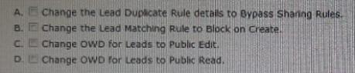
Ans: B D
- Universal containers has public read/write as the account org wide default (OWD) setting. Visitors to the universal containers customer community report that they can see all of universal containers’ account records. How should an app builder configure account sharing so that community users only see their own account?
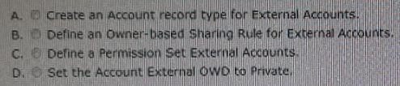
Ans: D
- Universal containers (UC) wants to deliver purchased containers to remote construction sites. These locations are missing a traditional street address. In these cases the customer will supply uc with the coordinates to the location. What type of field should the app builder use to capture this information?
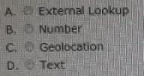
Ans: C
- Universal containers created a custom object called component to capture details about products sold. What approach should an app builder take to show component as a related list on product?
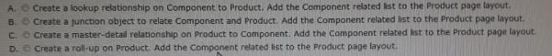
Ans: A
- Universal containers (UC) has 20 different workflows on the opportunity object. To ensure that updates are processing properly for all field updates; uc has the ‘re-evaluate workflow rules after field change’ checkbox checked. Recently after adding a new workflow, users have reported receiving errors about workflow limits. What should a app builder look at to address this issue?
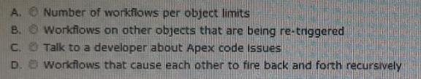
Ans: B (my own answering if possible pls confirm with trainer)
- Universal containers has a custom picklist called support level on the account object. They would like to show the real-time value of support level on all case records. How can an app builder implement this requirement?
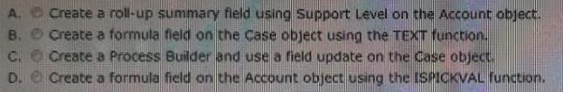
Ans: B
- Universal containers conducts evaluations of its sales reps using a custom object consisting of numerical scores and executive comments. The company wants to ensure that only the sales reps, their managers, and their manager’s executives can view the rep’s evaluation record, but also prevent the reps from being able to view the executive comment fields on their review. How can these requirements be met?
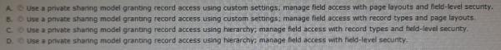
Ans: C (my own answering if possible pls confirm with trainer)
- Sales reps at universal containers use salesforce on their mobile devices. They want a way to add new contacts quickly and then follow up later to complete the additional information necessary. What mobile solution should an app builder recommend?
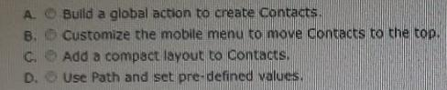
Ans: A
- Universal containers has two types of applicants, hourly and salary. There are separate record types for each. While all members of the human resource department need to be able to view all applicant records, only the hiring manager and vp of hr should be able to create salary applicant records. What should the app builder recommend to meet this requirement?
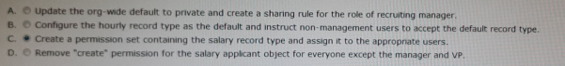
- Universal containers implemented an application process that uses custom objects internships and applicants. The organization-wide default for internships has been set to private and is the master in the master-detail relationship with applicants. The vp of hr wants to allow edit access to applications to recruiters. How should an app builder configure the proper access?
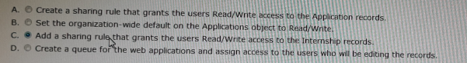
- Universal containers wants to ensure that they are accepting clean data from their users and verify that important fields are entered. What should an app builder recommend to meet this requirement?
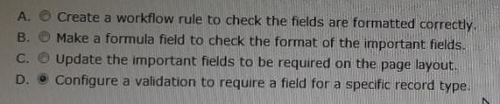
- Universal containers uses a custom object called projects. When managers assign projects they set a custom field on the project record called estimated hours. Once set, users should be able to decrease but not increase the value. How can an app builder meet this requirement?
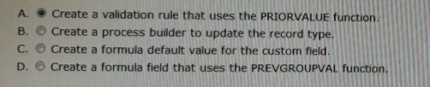
- Universal containers allows users to create standard reports on demand. What are two considerations users should be aware of when creating a new report?
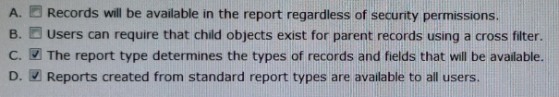
- A new field has been added to the applicant object. A recruiter ran the ‘position with or without applicants’ report and noticed that the new field was missing as an option to add as a column. How should an app builder troubleshoot this issue?
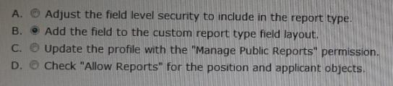
- Universal containers uses a custom object called reviews to capture information generated by interviews during the candidate process. The review records are visible to any user that has access to the related custom candidate record. The vp of human resources wants the comment field on the review to be private to anyone outside of the hr department. How should the app builder meet this requirement?
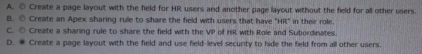
- How can an app builder configure access to a contact’s twitter profile for salesforce mobile app users?
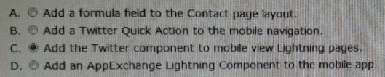
- When an opportunity is closed date is pushed more than 30 days, manager approval is required. An approval process is in place but reps frequently forget to submit for approval to run the process. How can an app builder ensure that these opportunities are submitted into the approval process?
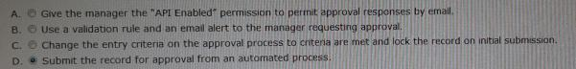
- Universal containers uses a private sharing model on accounts. User a and user b both own accounts of their own and have both sent a new account record in an email owned by user c to take a look at. User a is able to open and view the record but user b receives an insufficient privileges error. User a and user b have the same role in the role hierarchy as user c. What are the three reasons user a has access but user b is unable to access the record?
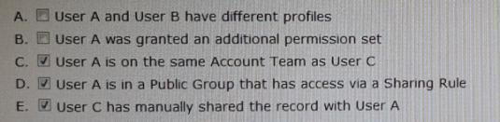
- Which feature should an app builder use to ensure that new leads are automatically sent to the appropriate sales rep?
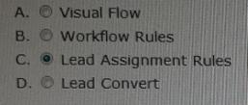
- An app builder has created a custom lightning app and wants to make it available to the internal users at universal containers. Which two steps are necessary to accomplish this task?
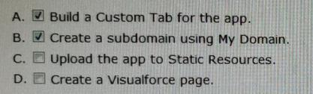
- Accounts at universal containers are currently readable by all users but editable only by their owners. Management wants to designate some accounts as vip accounts. Only account owners should have read access to these vip accounts. What two actions should an app builder take to meet the requirement?
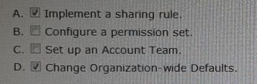
- An app builder wants to deploy a new version of an auto launched flow to production in an active state so that the new functionality is immediately available to users. What should the app builder take into consideration when planning the deployment?
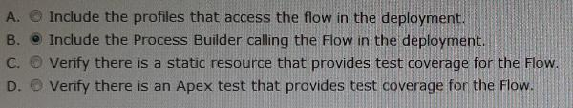
- At universal containers, each admin and developer use a separate developer pro sandbox. Configuration and code are then migrated to a partial data sandbox for combination and initial testing. Once approved the configuration and code are then migrated to a full sandbox for final load and regression testing before going to production. When should the full sandbox be refreshed?
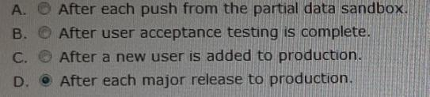
- Universal containers wants to understand return on investment for the latest advertising buy. They currently use a private security model for all objects. What should an app builder recommend?
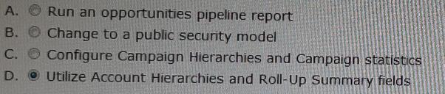
- Universal containers allows all employees to submit reviews for leadership using a custom object. These reviews should only be visible to the hr department and the employee who submitted the review. Which three steps should an app builder take to properly control access to review records?
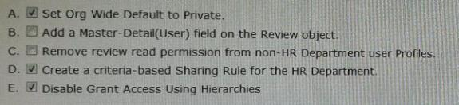
- Universal containers generates leads from three different sources: web, trade shows, and partners. Some of the information collected is applicable to all sources, there is also information that is unique to each type of lead. What should an app builder configure to meet these requirements?
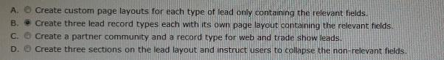
- An app builder has been asked to display an overdue date that is two months after a task’s due date. Which approach should the app builder take?
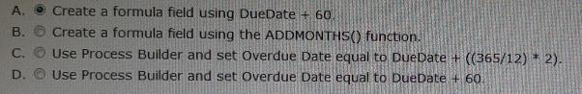
- Universal containers wants to display the real-time stock price for each account on the account record page. How should an app builder implement this request?
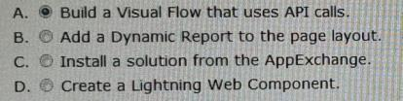
- At universal containers, all us sales reps should be able to view the us team dashboard. However, only the us sales directors should be able to see the data in the component and view its source report. How can an app builder ensure the proper access is granted?
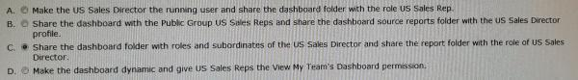
- The vp of sales wants a chatter post to the all sales private group when an opportunity goes to the closed won stage. What two tools should the app builder use to automate this process?
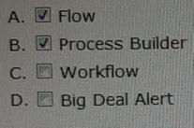
- The case handling process at universal containers includes multiple steps including approvals, notifications, and fields updates. To manage and evaluate all of these changes in a single save operation, an app builder wants to use process builder and the advanced option to let the process evaluate a record multiple times has been selected. What option should the app builder avoid to prevent recursion?
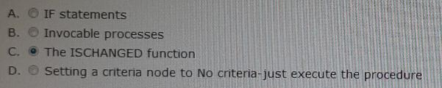
which two standard lightning page components are available in the lightning app builder
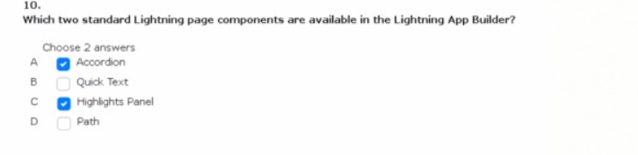
the director of customer service wants to receive a notification when a case stays in the new status for more than four business hours
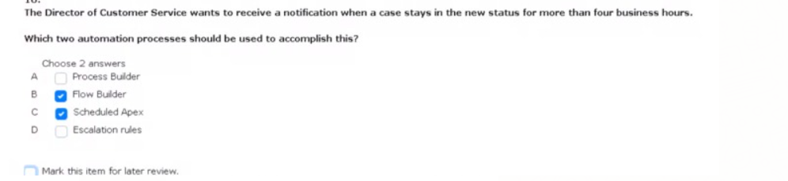

a customer service representative at cloud kicks wants to be able to collect information from customers using a series of question prompts .once the question are completed, an email should be sent to the customer with a feedback form
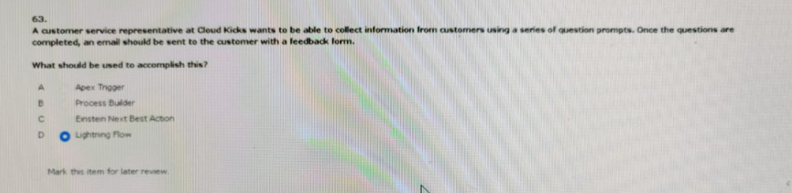
the vp of sales at cloudkicks wants to have a set of screams to guid the inside sales team through collecting and updating data for leads.once the leads are updated the leads should be entered into a marketing journey activated by the sales rep checking the marketing checkbox
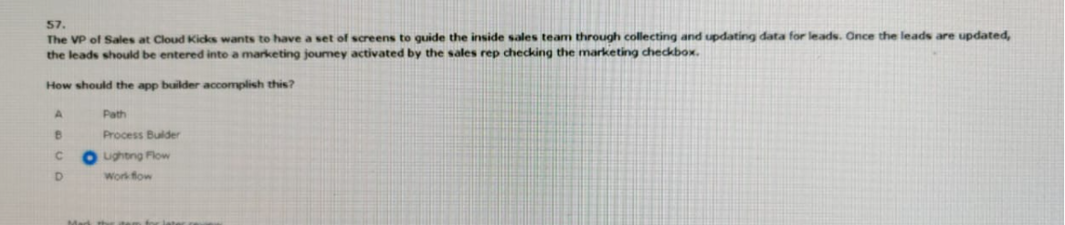
users aat cloud kicks provided feedback that the time card custom page layout has too many fields on it and some fields are only needed it other fields are entered
what should an app builder configure to help with this issue
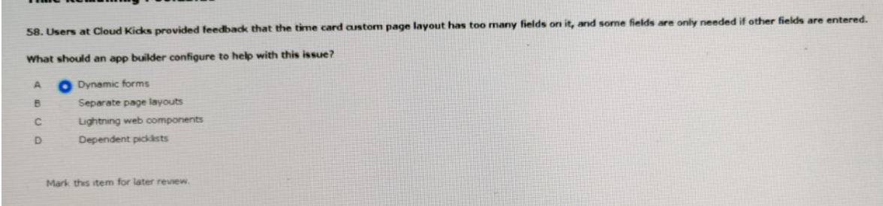

which two capabilities should an app builder consider when using an external id field?
